1. Find the class average for the subject ‘Physics’
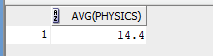
2. Find the highest marks for mathematics (To be displayed as highest_marks_maths).
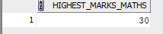
3. Find the lowest marks for chemistry(To be displayed as lowest_mark_chemistry)
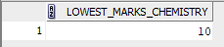
4. Find the total number of students who have got a ‘pass’ in physics.
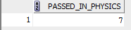
5. Generate the list of students who have passed in all the subjects
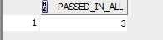
6. Generate a rank list for the class. Indicate Pass/Fail. Ranking based on total marks obtained by the students.
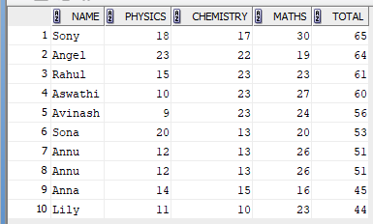
7. Find pass percentage of the class for mathematics
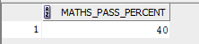
8. Find the overall pass percentage for all classes.

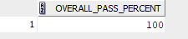

9. Find the class average
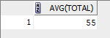
10. Find the total number of students who have got a Pass.
